**To change competitor names or drop an entry, log into your account on tabroom. Click on your email in the upper right. This will take you to a screen of tournaments you’re registered for – click on the tournament you are trying to change names or drop entries.**

**This is what you will see when you login to your account and click on the Tournament you wish to change your entries for.**

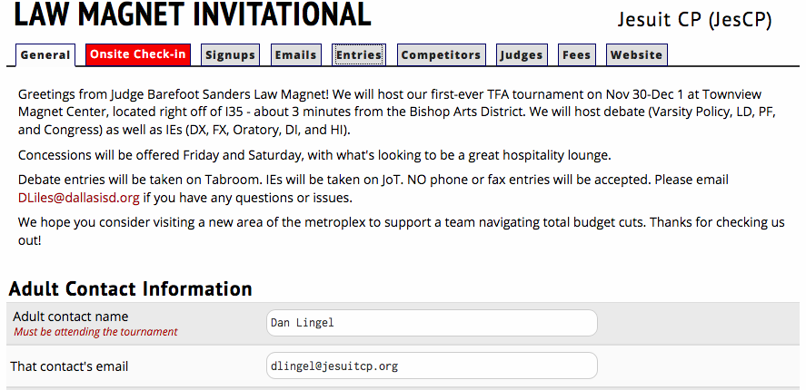

**Click on Entries**

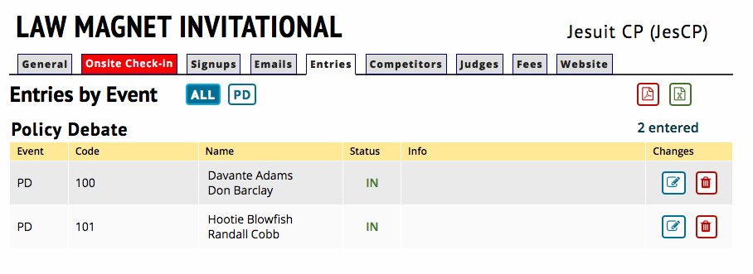

**Once you click on entries, you can drop the entry by clicking the trash can next to the team you wish to drop. Only do this if you are dropping the whole team – both competitors and do not want the slot anymore.**

**If you need to change a name of a competitor (but one remains the same) OR if you need to change both names, click on the pencil/clipboard icon. For the competitor you want to swap out, drag down the box and select the new name of the person who will compete. You need to have added the new person to your team roster.**

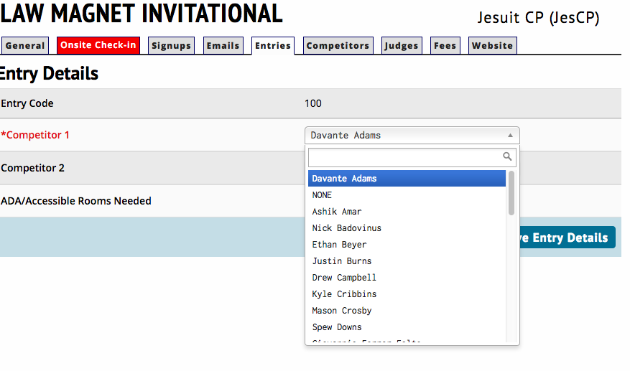

**Once you have changed the name, you should save entry details.**

