We appreciate your work to create a school for registration!
Click the "Sign Up" link in the upper right hand corner of the page:
Then, fill out the form and click "Create Account:"
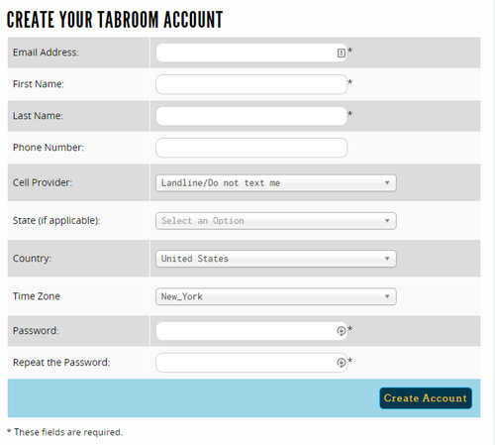
You can use any email address you like to sign up. If you put in your cell phone number and choose your provider, you will be able to receive texts from tournaments you attend with pairings, information, etc.
Once you have signed up, you will be given a number of options to get started, whether you're a coach, a student, or a tournament director:
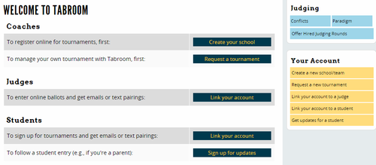

Creating A School
If your school doesn't exist in Tabroom yet, you'll need to create it. After logging in, click the link for "Create a new school/team" in the sidebar:
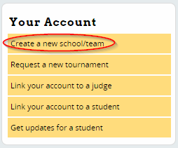
Then, fill out the required information such as School Name, State, etc. When done, press Save School Info.
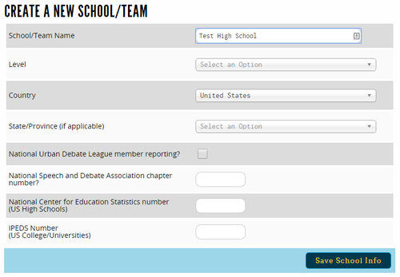
If a school already exists in Tabroom with a similar name, you will see a warning that says "THAT INSTITUTION ALREADY EXISTS!"
If you need help getting access to an existing school, email [[mailto: help@tabroom.com]]. If you're sure you need to create a new school, check the "Confirm duplication" box:
Once your school is created, you should see a welcome message telling you what to do next
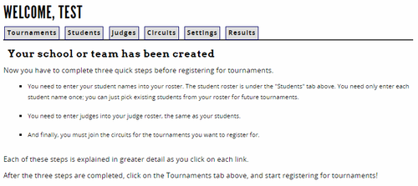

Circuits
In order to register for a tournament, you must first join the appropriate "circuit." All tournaments on tabroom must be part of a "circuit" - to find out which circuit the tournament you're interested in is a part of, look on the main Calendar.
Then, use the "Circuits" tab to join the circuit:
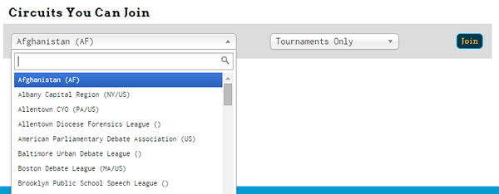
First, select the circuit you want to join from the dropdown – You want DUDA Then, choose "Full Membership."
"Full Membership" means you will be able to register for tournaments, and will receive emails about the circuit.
Once you have joined DUDA circuit , your Circuits tab will change to show you the list of tournaments your school is a part of. Then you will be ready to register
