Registering teams for a tournament
Log into your tabroom account. If you don’t know what your password is, you can reset it.
When you log in, you will see some tabs at the top.
Before you can register for a tournament, you must have first have added students to your student roster.
Look at the tabs at the top - Click on tab says that says Competitor.
To add students to a roster,
Click the "Add a new student" link on the sidebar at the right:
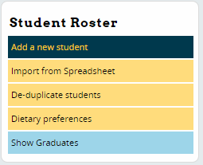
You can manually enter their information and click the "Save Student" button. You just need to have their names. You don’t need any other information in order to register them.
Once you have added all the students you need to the roster, click on the tournaments tab at the top.
Once you do that, you will see list of tournaments open for registration.
Click on MS Tournament 1.
Click on the Entries tab on the top.
On the right you will see Add Entry to: above a “choose and event” drop down. Pick the division you want to enter students in.
That will take you to slightly different page. You will see Add entry to ACX or BCX (depending on what division you selected). You will see the first names of the students on your roster – select the name of the student you wish to enter. Then in the second box, select there partner’s name.
Click add entry.
If you have forgotten to enter someone on the roster and you need their name, then click on add new competitors right below. This will allow you to do the step I described above.

Judges
If you have coaches or parents who could judge (we will try to not use them if possible), add them as well to the judge roster then add them into the
The judge roster works very similar to the student roster. You can click the "Add a new judge" link in the sidebar, or if your judge roster is empty, the form will appear automatically:
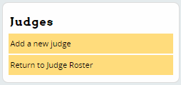
You can manually enter their information and click the "Save Judge" button.
Go back to entries by clicking on the entries tab. You can then select “add a judge”. Select the name of the judge from your roster of judges. Click
The judge will have to create a tabroom account. They can do that by clicking on sign up on tabroom. They should be sure to ask to link their account to your school – you will then get a request on your account page to give permission to link to your school.

